MBA342B – PYTHON FOR DATA ANALYSIS
CIA 3

BANK CUSTOMER CAMPAIGN RESPONSE SYSTEM

A Report submitted in partial fulfillment of the requirements for the degree of
Master of Business Administration

By
SANIA FATHIMA
REGISTER NUMBER – 2527050

Under the Guidance of
PROF. HELEN JOSEPHINE V L


MBA PROGRAMME
SCHOOL OF BUSINESS AND MANAGEMENT
CHRIST (DEEMED TO BE UNIVERSITY), BANGALORE
MARCH 2026
BANK CUSTOMER CAMPAIGN RESPONSE SYSTEM
Mini Project Report

1. Introduction
Banks frequently conduct marketing campaigns to promote financial products such as loans, credit cards, insurance plans, and savings schemes. Identifying customers who are most likely to respond to these campaigns helps banks improve marketing efficiency and increase product adoption.
Managing large volumes of customer information manually is difficult and time-consuming. Therefore, an automated system that can store, manage, and analyze customer data is necessary.
The Bank Customer Campaign Response System is a Python-based application designed to manage customer information, banking transactions, credit history, campaign results, and customer support requests.
The system stores data in CSV files, which act as a lightweight database. Python’s file handling and CSV modules are used to read and write data.
The system provides two types of access:
- Bank Manager Portal – used to manage customer data and perform campaign analysis.
- Customer Portal – used by customers to view their profile, check balance, check credit score, and raise support requests.
This project demonstrates how Python can be used to create a simple banking Customer Relationship Management (CRM) system.

2. Objectives
The main objectives of this project are:
- Maintain customer records
- Track banking transactions
- Store credit history information
- Calculate customer credit scores
- Analyze customer eligibility for marketing campaigns
- Maintain campaign prediction results
- Handle customer support requests
- Provide a simple prototype of a banking CRM system

3. Technologies Used
Technology | Purpose
Python | Programming language used to implement the system
CSV Files | Data storage for customer and banking data
File Handling | Reading and writing data from CSV files
Jupyter Notebook | Development and implementation environment

4. System Architecture
The system consists of two main users:
4.1 Bank Manager
The bank manager is responsible for managing customer data and performing campaign analysis.
Manager functions include:
- Add customer records
- Record transactions
- Update credit history
- Run campaign analysis
- View customer support requests
4.2 Customer
Customers have limited access to the system. They can perform the following operations:
- View their profile
- Check account balance
- Check credit score
- Check campaign eligibility
- Raise support requests

5. Database Design (CSV Files)
The system uses CSV files as the database to store all information.
The project uses five CSV files:
- customers.csv
- transactions.csv
- credit_history.csv
- campaign_results.csv
- support_requests.csv
Each file stores different types of data required for the system.

5.1 customers.csv
This file stores personal information of bank customers.
Fields
CustomerID, Name, Age, Job, MaritalStatus, Education
Example
101,Arjun,35,Manager,Married,Graduate
102,Riya,28,Engineer,Single,Postgraduate

5.2 transactions.csv
This file stores customer banking transaction details and account balance.
Fields
CustomerID, Balance, LastTransaction, TransactionType
Example
101,5000,2000,Deposit
102,3000,500,Withdrawal

5.3 credit_history.csv
This file stores credit-related information used to calculate credit score.
Fields
CustomerID, PreviousLoans, RepaymentHistory, MissedPayments
Example
101,1,Good,0
102,3,Poor,2

5.4 campaign_results.csv
This file stores campaign prediction results generated by the system.
It identifies whether a customer is likely to respond to marketing campaigns.
Fields
CustomerID, Prediction
Example
101,Likely Subscriber
102,Not Likely Subscriber

5.5 support_requests.csv
This file stores customer complaints or support requests.
Fields
RequestID, CustomerID, Issue, Status
Example
1,101,ATM card not working, Open
2,102,Need loan information, Resolved

6. System Modules
6.1 Customer Module
The customer module allows customers to access their personal banking information.
Customers can perform the following operations:
- View profile information
- Check account balance
- Check credit score
- Check campaign eligibility
- Raise support requests

6.2 Manager Module
The manager module allows bank employees to manage system data and perform analysis.
Managers can perform the following operations:
- Add new customer records
- Record customer transactions
- Update credit history
- Predict credit score
- Run campaign analysis
- View customer support requests

7. Credit Score Logic
The system calculates a credit score for each customer based on their credit history and financial behaviour.
Base Credit Score
600
Score Adjustments
Condition | Score Change
Good repayment history | +80
Balance greater than 3000 | +40
Missed payments | -100
More than 2 previous loans | -50
Credit Score Range
300 – 850

8. Campaign Prediction Logic
The system predicts whether a customer is likely to respond to a marketing campaign.
A customer is classified as Likely Subscriber if:
- Credit Score > 680
- Balance > 2500
Otherwise, the customer is classified as:
Not Likely Subscriber
The prediction results are stored in campaign_results.csv.
9. Menu Structure
Main Menu
BANK CUSTOMER CAMPAIGN RESPONSE SYSTEM
1 Customer Portal
2 Bank Manager Portal
3 Exit

Customer Menu
1 View Profile
2 Check Balance
3 Check Credit Score
4 Check Campaign Eligibility
5 Raise Support Request
6 Back

Manager Menu
1 Add Customer
2 Record Transaction
3 Update Credit History
4 Run Campaign Analysis
5 View Support Requests
6 Back

10. Python Implementation (Jupyter Notebook)
The system is implemented using Python in Jupyter Notebook.
Key implementation features include:
- CSV file handling using csv.DictReader and csv.DictWriter
- Modular functions for each operation
- Menu-driven command line interface
- Credit score calculation algorithm
- Campaign prediction logic
Each module is implemented as separate functions within notebook cells.

11. Entity Relationship (ER) Diagram
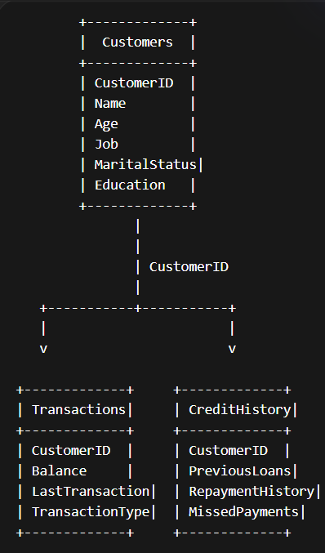
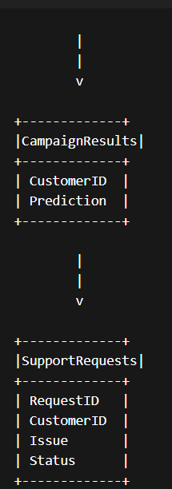
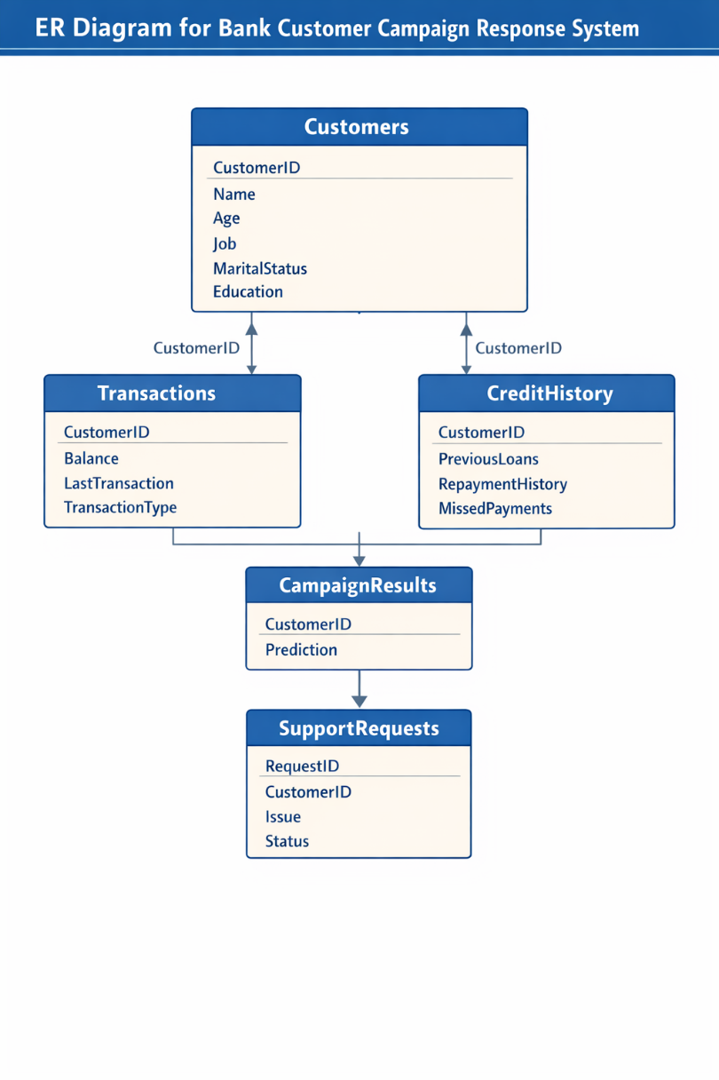
12. Process Flow Diagram
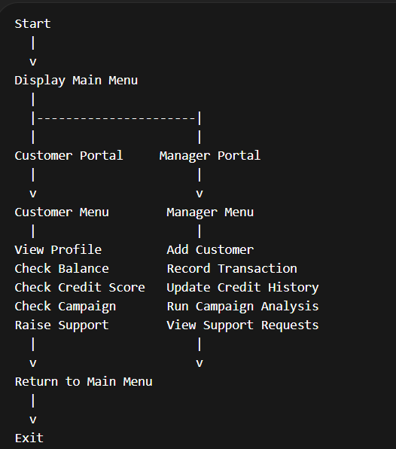
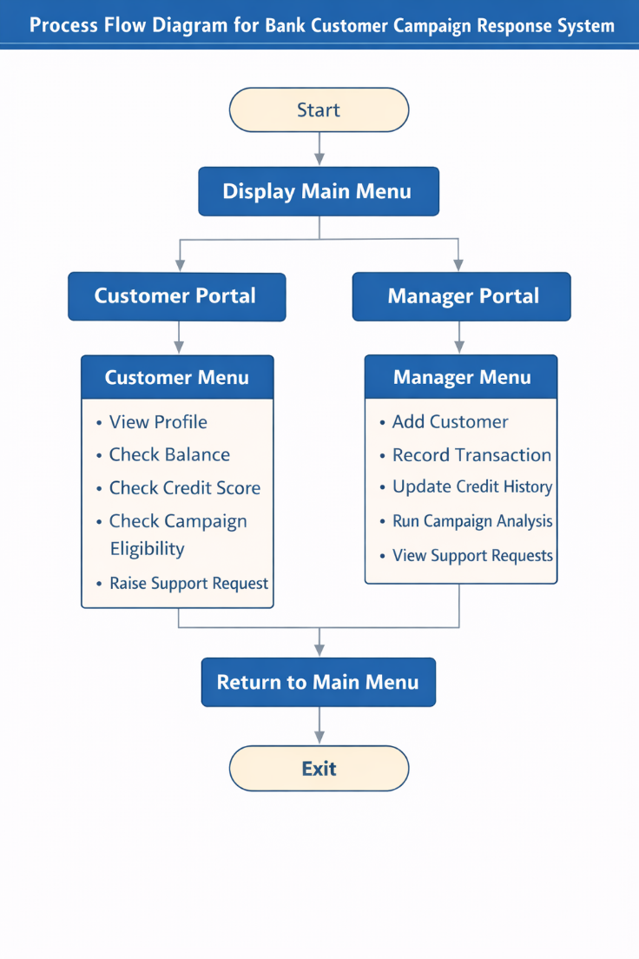
13. Conclusion
The Bank Customer Campaign Response System demonstrates how Python can be used to develop a simple banking management application using CSV files as a database.
The system successfully manages customer records, transactions, credit history, campaign predictions, and support requests. It also includes a basic algorithm to predict whether a customer is likely to respond to marketing campaigns.
This project provides practical experience in Python programming, file handling, data management, and system design.
In the future, the system can be improved by integrating:
- A graphical user interface (GUI)
- A relational database such as MySQL
- Machine learning models for more accurate campaign prediction
The project serves as a strong foundation for developing more advanced banking information systems.

